Optical flow estimation techniques

**Optical flow**

Optical flow estimation involves calculating the motion of objects between consecutive frames in a video sequence

There are two main optical flow estimation techniques as **Lucas - Kanade** Method and **Horn-Schunck** method which have been discussed on the paper [1].

**Lucas - Kanade Method(LK)**

The LK method is a local technique to assume motion in a small, local neighborhood. It assumes that nearby pixels share the same motion. To figure out the movement, it uses least squares regression over a small window. This method works well when the image texture is well-defined.

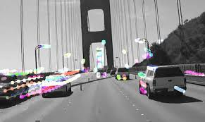

**Applications of LK**

1.Real time object tracking - LK's efficiency makes it suitable for tracking objects in real-time applications like surveillance systems, autonomous vehicles, and human-computer interaction.

2.Motion estimation - LK is used to estimate the motion of objects in videos for tasks such as motion compensation, video stabilization, and video synthesis.

3.Image Registration - LK is employed to align medical images from different modalities or time points, facilitating accurate diagnosis and treatment planning.

4.Object Tracking - LK can be used to track real-world objects, allowing virtual objects to be seamlessly integrated into the scene.

**Horn - Schunck Method(HS)**

The HS method is a global approach to optical flow estimation. It assumes that the movement is smooth everywhere, even where the details are not detailed. Even though this works well in fast moving objects, it may make the edges of the object blurred. The reason for this is it tries to keep the motion smooth in the whole image.

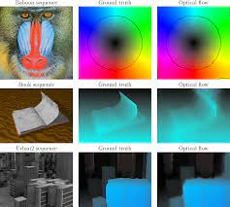

HS with multi scale

**Applications of HS**

1.Fluid flow analysis - HS is used to visualize fluid flow patterns in scientific simulations and experiments.

2.Wind field estimation - HS is used to estimate wind fields from satellite imagery, aiding in weather forecasting and climate modeling.

3.Blood flow analysis - It can help analyze blood flow patterns in the heart and vessels.

4.Crowd analysis for security - HS can be used to analyze crowd movements and detect anomalies, such as potential security threats. It can be used to track objects in crowded scenes, even when there are occlusions or changes in appearance.

**Comparison between LK and HS**

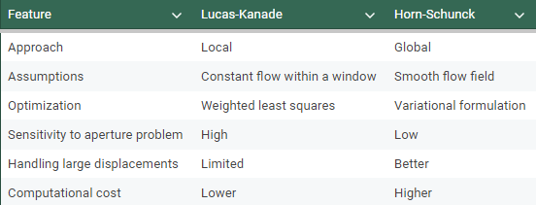

* Area of Focus - LK focuses on small parts, while HS looks at the whole image.
* Assumption - LK assumes the same motion in small areas, while HS assumes smooth motion overall.
* Calculation - LK compares pixels within windows, while HS considers the whole image and its smoothness.

Both methods are widely used in computer vision for tasks like object tracking, motion analysis, and stereo matching.The choice between LK and HS depends on the specific application and the desired properties of the motion field.In practice, hybrid methods that combine elements of both LK and HS are often used to achieve better performance.

**Reference**

[1] A. M. G. Pinto, A. P. Moreira, P. G. Costa, and M. V. Correia, “Revisiting Lucas-Kanade and Horn-Schunck,” *Journal of Computer Engineering and Informatics*, vol. 1, no. 2, pp. 23–29, Apr. 2013, doi: 10.5963/jcei0102001.